Instructions to enable NCI SSO Module for CRADA Web Application
This document is a step by step instructions describing how to properly enable and configure the SSO module for the CRADA web application.
Copy nci_SSO folder from <dev-crada-server>:/local/drupal/crada-dev/sites/all/modules to <crada-qa-server>:/local/drupal/crada-qa/sites/all/modules
Login as local user admin to https://crada-qa.nci.nih.gov

Step 1: Enable NCI SSO Module (nci_SSO) module.
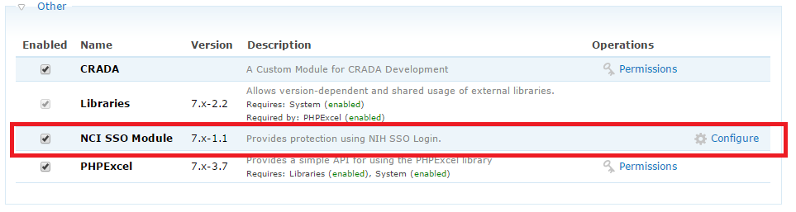
Update /local/drupal/crada-qa/sites/all/modules/nci_SSO/nci_SSO.module to replace crada-dev with crada.nci.nih.gov
Enable both CRADA and nci_SSO module
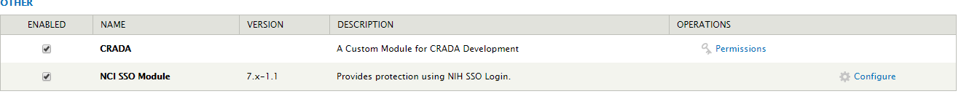
Step2: Configure NCI SSO Module.
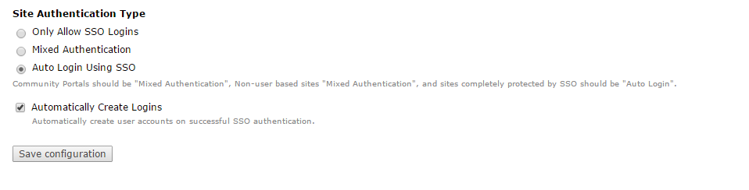
Step 3: Configure Administrator role
- URL <crada root>/admin/config/people/accounts
- Click People -> Permissions -> User Settings
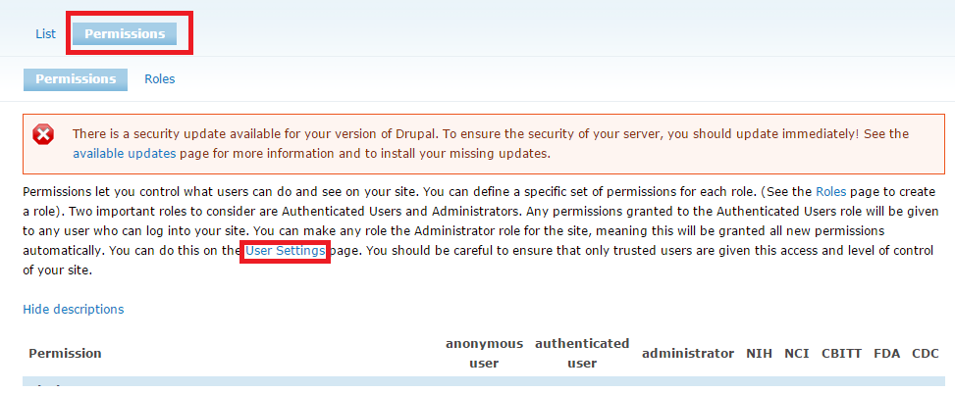
- Select administrators for Administrator Role
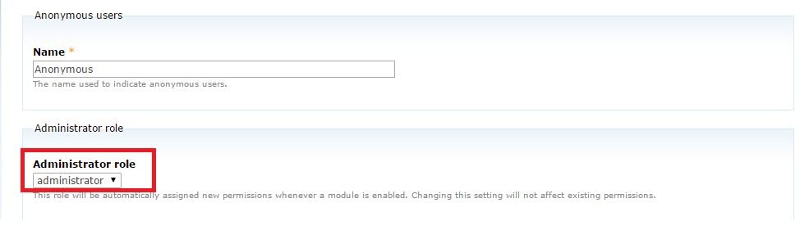
Step 4: Add user permissions for administrators
- URL <crada root>/admin/people/permissions
- Click People -> Permissions
- Enable Administer permissions and Administer users for the administrator role
